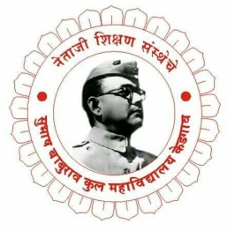
Netaji Shikshan Sanstha's
 | Subhash Baburao Kul Arts, Commerce & Science College
Kedgaon, Tal: Daund, Dist: Pune-412203
D Department of Food Processing Technology
SYLLABUS COMPLETION REPORT

To,
The Principal,
S.B.Kul Arts, Commerce & Science College,
Kedgaon.412203.

Subject: Syllabus Completion Report For The Academic Year 2021-22.

Respected Sir,
I am Prof. Gaikwad Omkar mention that I have been given the following subject for teaching. I assure that I have completed the syllabus as per teaching plan of theory & practical subject satisfactorily.
The syllabus completion details are as follows:
Date:29/04/2022
Class |  | Sem. | Subject Code | Name of Subject | Unit / Chapter | No. Of Lecture allotted per Week | No of Lecture taken to complete | Syllabus Completed (Month)
F. Y.  FOOD |  | I | VFP1S02PB | Communication Skills in English ( Practical) | 1. Grammar | 6 | 20 | July
 |  |  |  |  | 2. Listening |  | 10 | Aug
 |  |  |  |  | 3. Speaking |  | 20 | Aug
 |  |  |  |  | 4. Reading |  | 20 | Sep
 |  |  |  |  | 5. Writing |  | 20 | Oct
F. Y.  FOOD |  | II | VFP2S05PB | Critical Thinking, Academic Writing and Presentation Skills | 1. Critical Thinking | 6 | 20 | Jan
 |  |  |  |  | 2. Research for Academic writing |  | 20 | Jan
 |  |  |  |  | 3. Writing Process |  | 15 | Feb
 |  |  |  |  | 4. Writing Models |  | 15 | Mar
 |  |  |  |  | 5. Presentation Skills |  | 20 | Apr

Thanking you,
Yours Faithfully,
Prof. Omkar Gaikwad

